1. Agenda:
   1. Discussion on Pre-insert Identifier (ID) Generation Strategy.  
      We will try to understand this by using GenerationType.SEQUENCE as this is Pre-insert Identifier (ID) Generation Strategy.
   2. 
2. 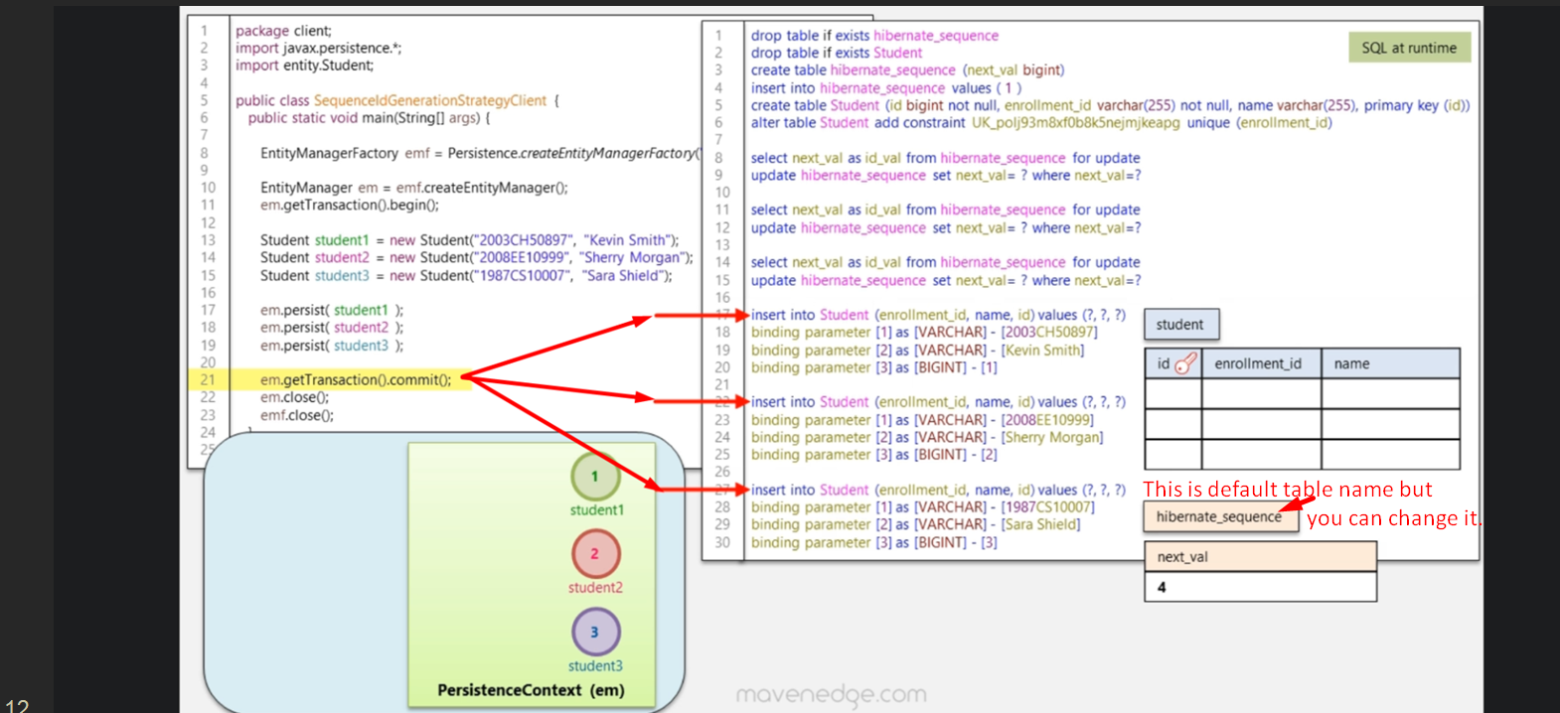
3. What is Sequence in case of DB?
4. It is a feature provided by some relational database management systems to generate unique sequential numeric values for you.  
   The job of DB Sequence is that whenever you call it, it returns unique value.
5. But how do we create this table?
6. 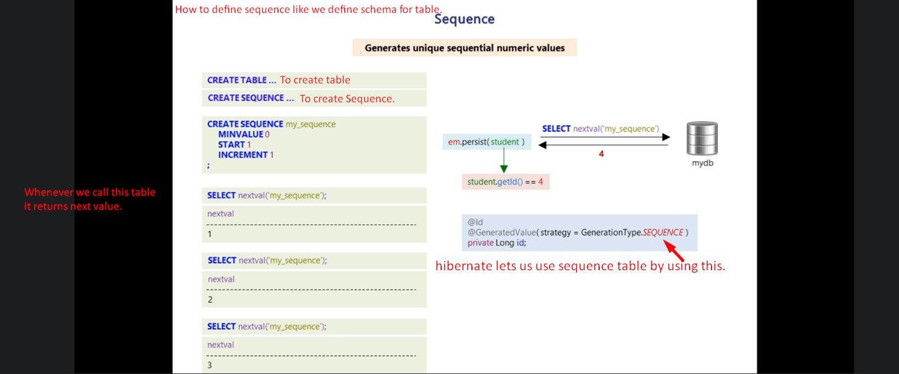
7. 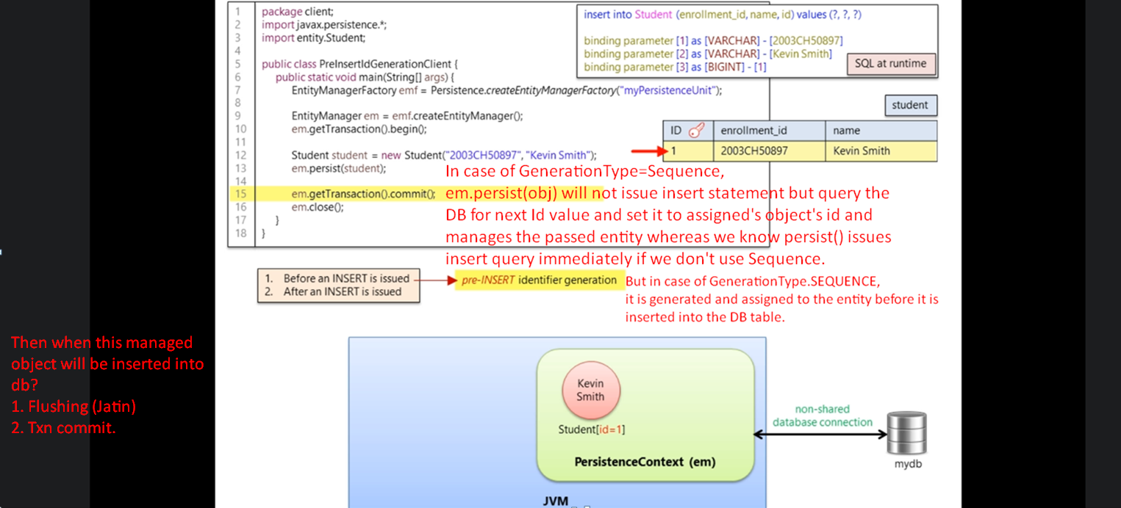
8. 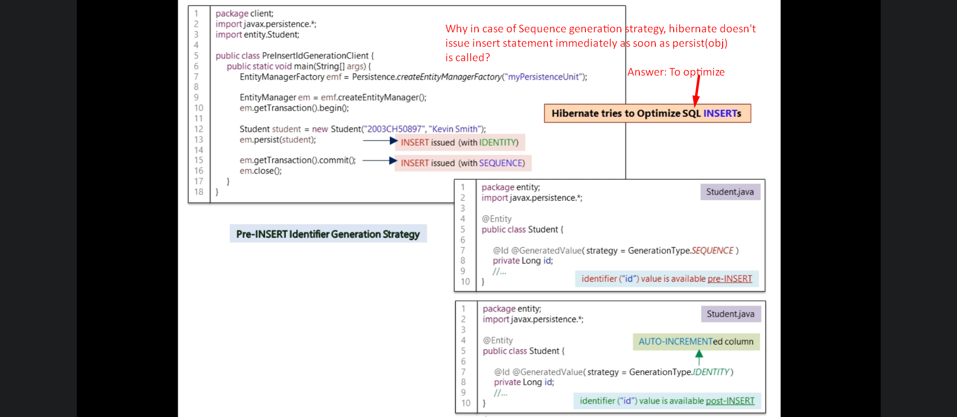
9. 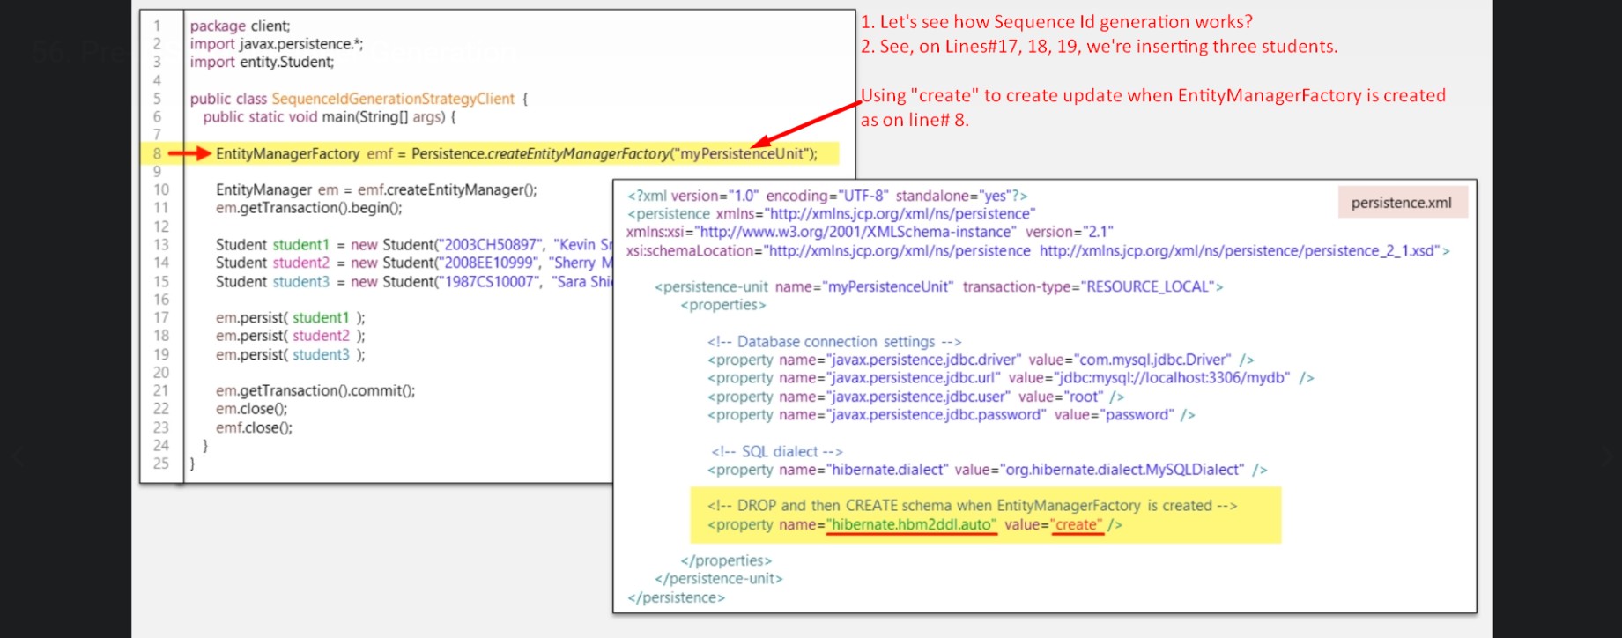
10. 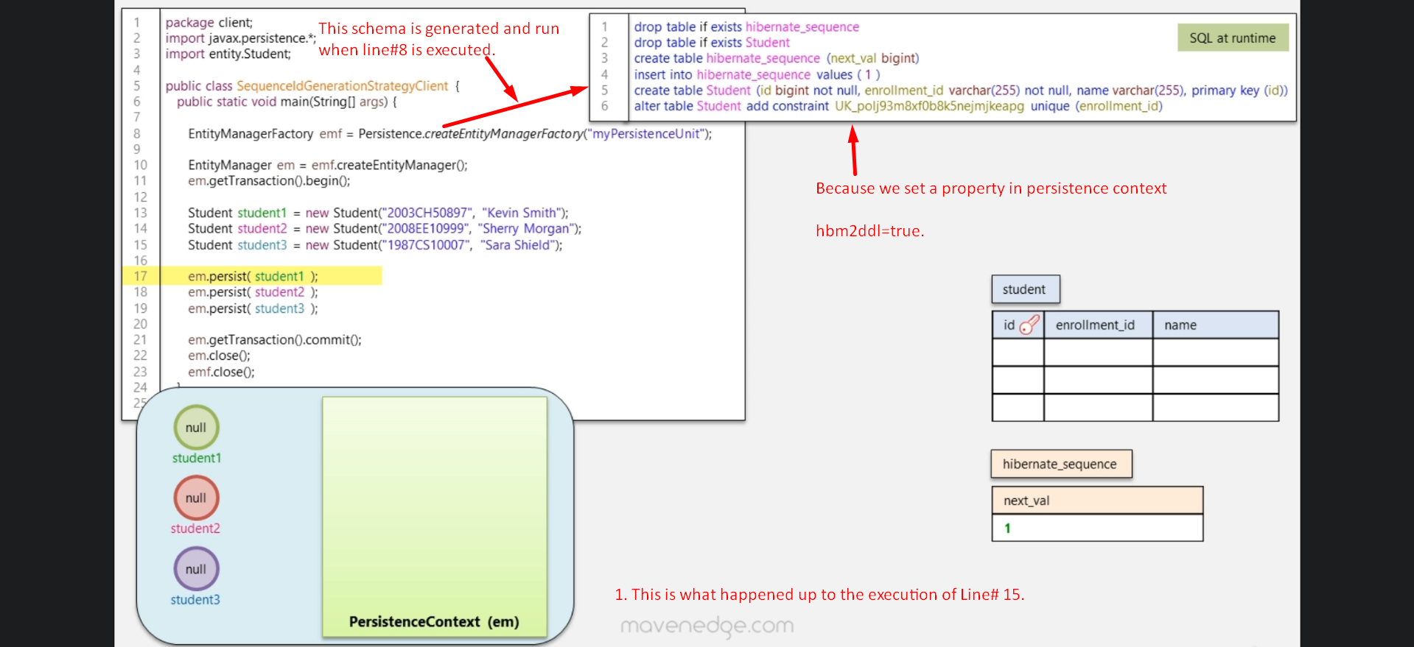
11. 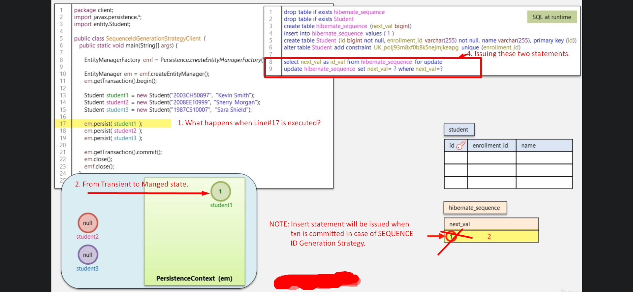
12. 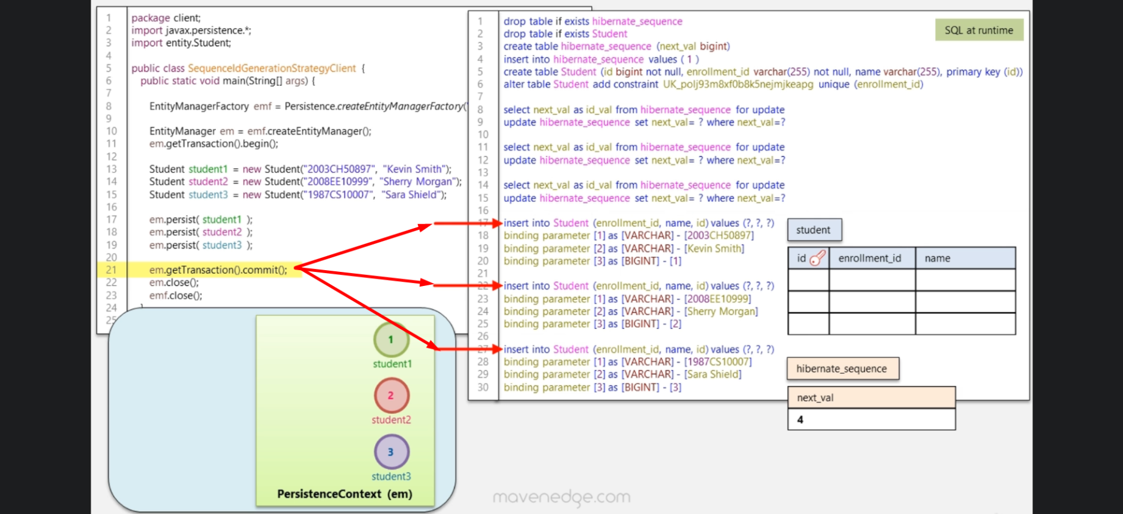 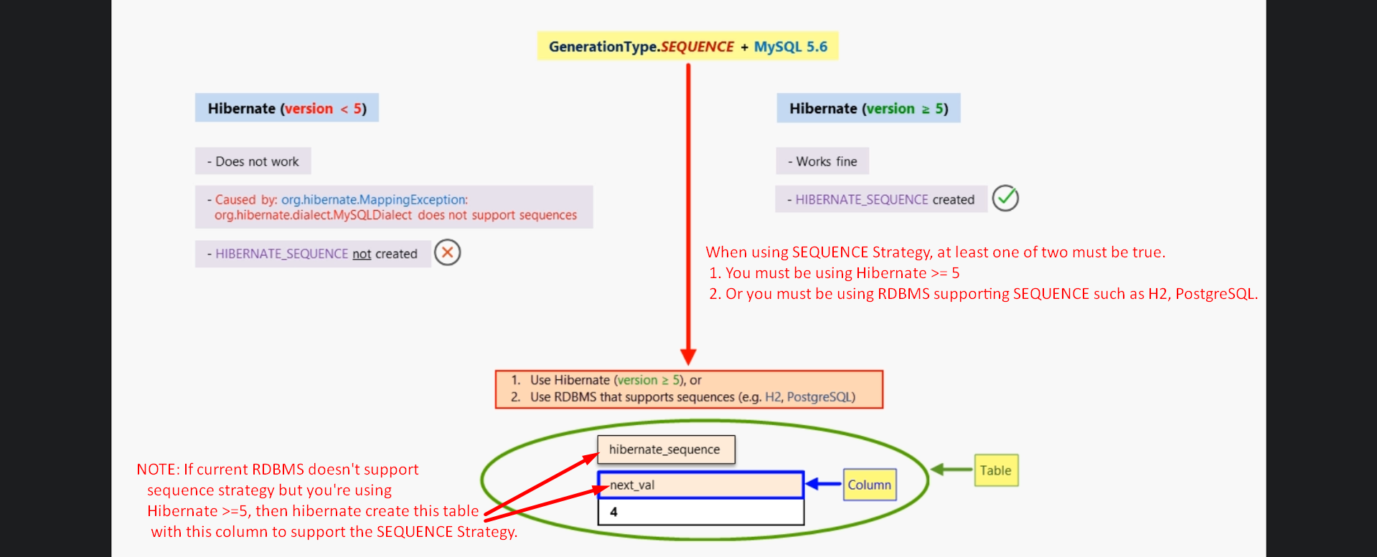
13. 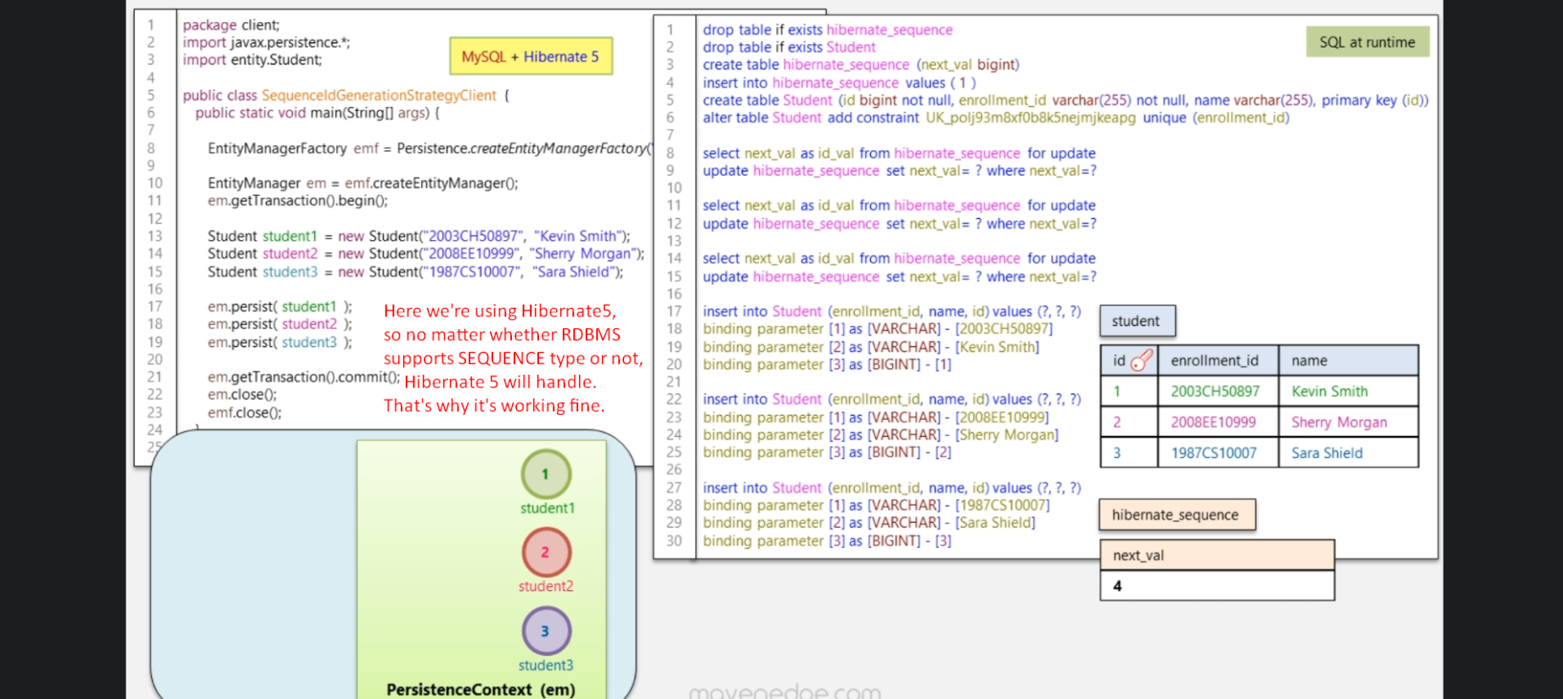
14. 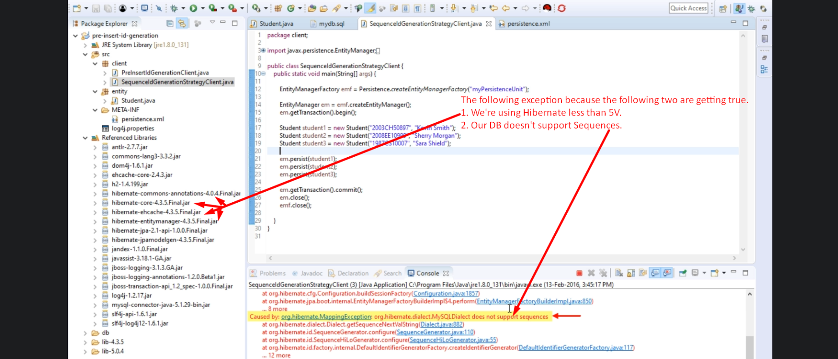
15. 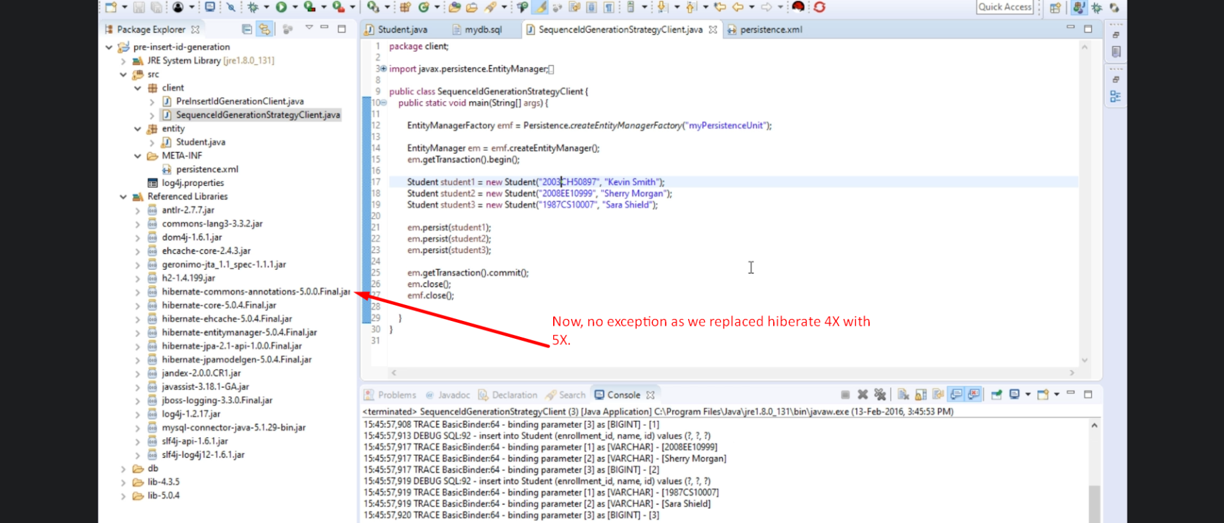
16. 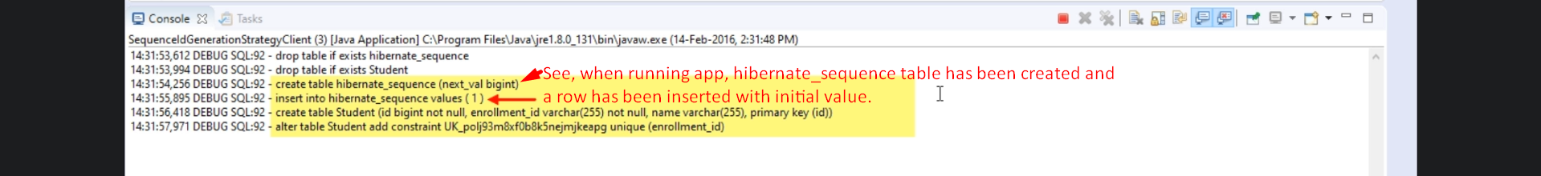
17. 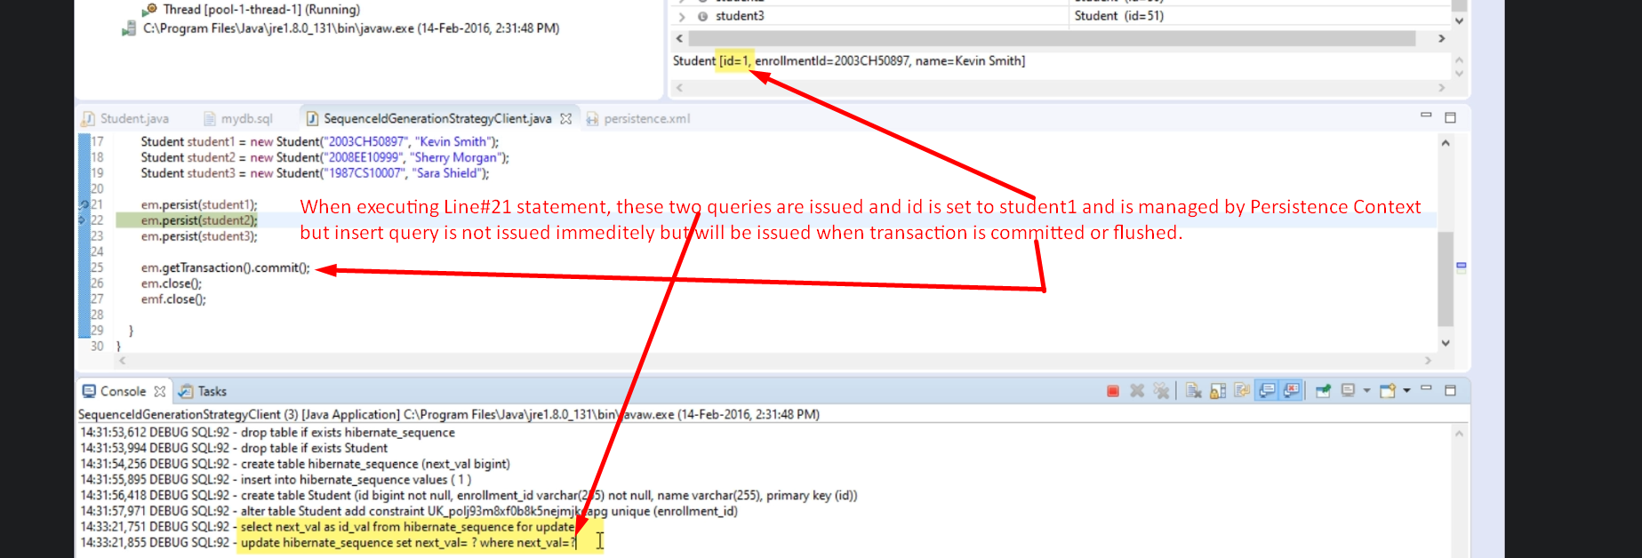
18. 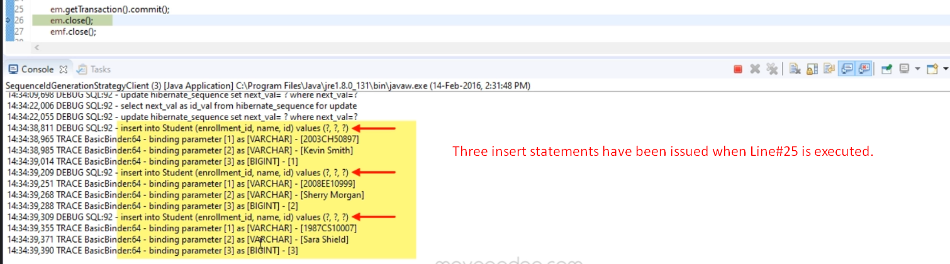
19. 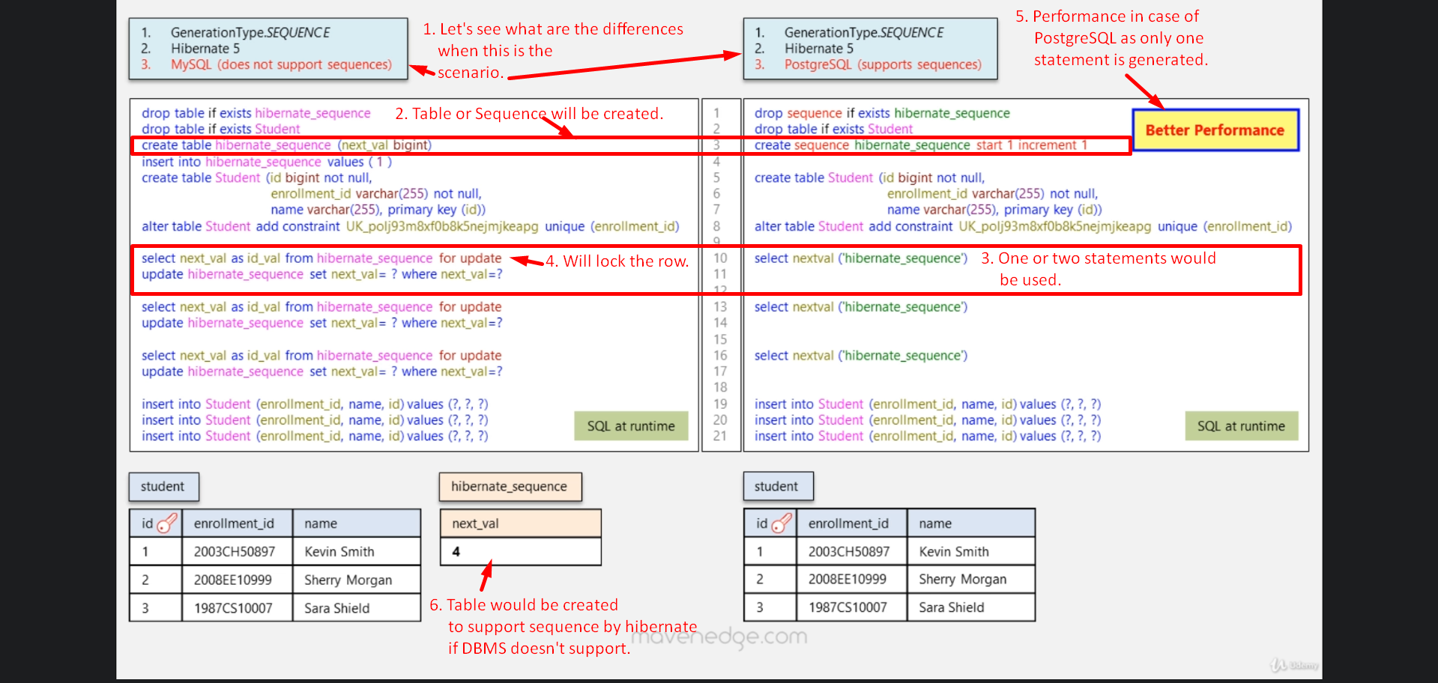
20. Let’s talk about other Pre-Insert Identification Generation Strategy.
21. Pre-insert Identification Generation Strategy: When calling persist(Object), only Database ID is assigned, no insert statement is issued.
22. GenerationType.TABLE: This is also pre-insert identification Generation strategy.
23. 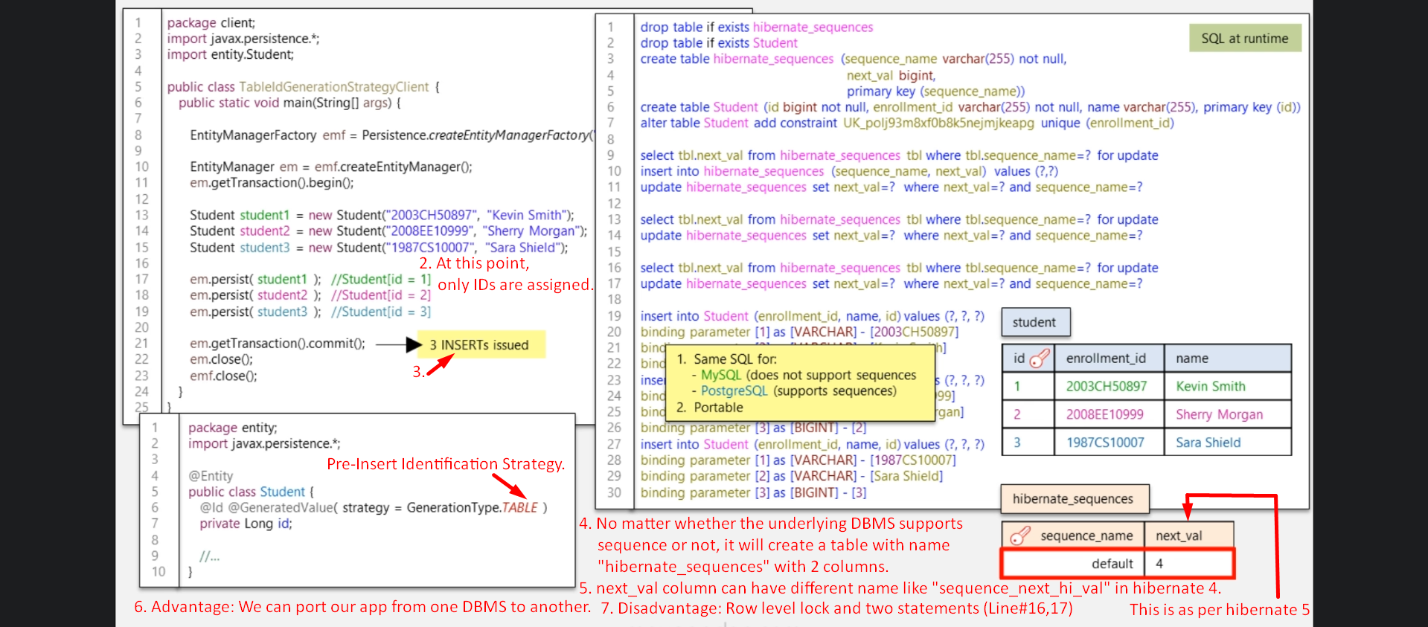
24. 